Delaware township
Home of the One Room School Museum
Spring/Summer 2015 Newsletter 53 Oniontown Road ~ Greenville, PA 16125
Board of Supervisors

Daniel K. Micsky
Chairman

John E. Lesnett
Vice-Chairman

William E. Anthony
Supervisor

Melissa L. Osborne
Secretary/Treasurer

Kristan L. Eastlick
Assistant Secretary

Office Hours
Tuesdays, Wednesdays & Thursdays
8am – 4pm

Phone: 724-588-2040
Fax: 1-800-834-0351
Email: delawtp@gmail.com
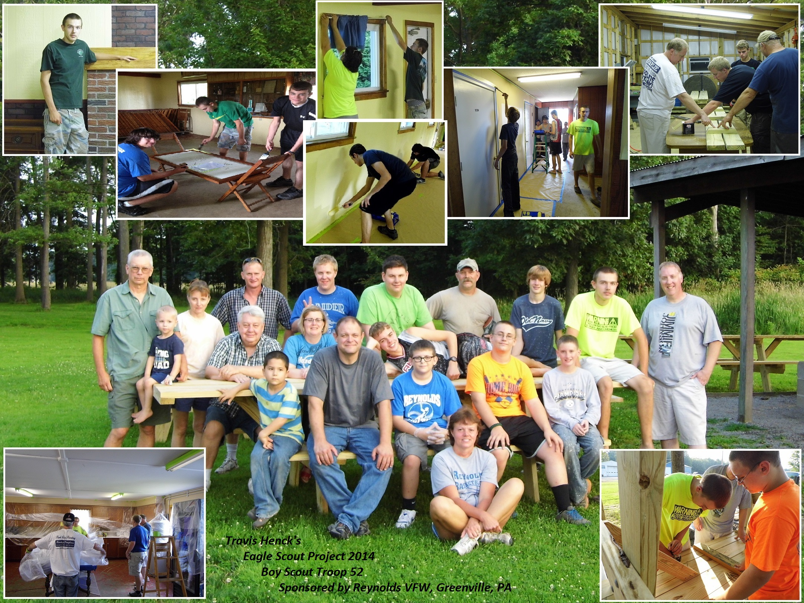

spring bulk clean-up week june 1st-5th
The spring bulk clean-up day for township residents is the week of June 1, 2015 on their regular collection day. Please place debris within five feet of the road the night before. No electronics will be accepted. The same items that have NOT been accepted in the past still apply. If you do not have regular weekly trash service or purchase trash tags, you will NOT be able to participate the in the clean-up day. Any questions please call Tri-County at 724-662-2510 or the township office at 724-588-2040.

NEW WEBSITE
The township now has a new website full of information. Please take the time and check it out at www.delawaretownshipmc.com. We want to say a special thank-you to our area businesses that sponsored the website and are featured on the home page in our business spotlight section. If you have a business in the township and would like to be featured please call the township office for more details.

MErcer Area Library
The Board of Supervisors voted on and approved becoming a member of the Mercer Area Library. Township residents please take advantage of this service as every resident will be entitled to a free library card and all the other great services that are offered. Library hours are Tues., Wed., Thurs., Fri., from 9:30-8:00. Sat., 9:00-4:00 and closed Sunday and Monday.

The township picnic
Please join us on Sunday, August 23rd, 2015 from 2-5 pm for the annual township picnic to be held at the park building. Last year was a great turn out and wonderful time by all. We hope to see everybody this year! RSVP requested but not required. All food and beverages will be provided. 724-588-2040.

eagle scout project
Travis Henck, a Reynolds High School Junior worked very hard along with his fellow members of his troop building new picnic tables and painting the inside of the park building. We thank them very much for this wonderful service project that they provided for all the residents of the township to enjoy. Congratulations Travis on earning your wings.

BUILDING PERMITS

As we are approaching warmer weather it also brings the season of construction. Just a friendly reminder to obtain a permit before you start!
For more information go to www.richardsoninspectionservices.com.
ANTICIPATED ROADS FOR SEAL COAT SUMMER 2015

Be the next business to sponsor the township newsletter.

For more information to sponsor the next township newsletter contact the township office at
724-588-2040

Bend Hill Road; Fry Road; Homer Road; Keystone Road and River Road.
Please use extra caution during this construction time.

Delaware Township Park Building Rental
Delaware Township
53 Oniontown Road
Greenville, PA 16125

Book now for your summer 2015 graduation parties, reunions, and picnics.
Please call the township office at 724-588-2040. Dates are going fast. Summer rates for township residents is $85.00.

Housing rehabilitation
Delaware Township is part of the Lackawannock HOME housing Rehabilitation grant program. Residents who are income eligible can have home repairs and/or improvements done. We encourage you to call the township office for more information or to obtain an application. This grant has helped many township residents already.
PROPERTY/RENT TAX REBATE
Residents who meet the following criteria may qualify for a property tax rebate: 65 years or older, disabled, or widowed. Must apply by June 30, 2015. Maximum income is $35,000.00. Please contact Debra Rodemoyer for more information: 147 Oniontown Road, Greenville, PA 16125. 724-475-4331.
TOWNSHIP HUMOR

By
The Old Hickory Nut
(Original was typed as submitted)
Sunshine, we finally got through the winter that never quit, or so we think. Might be its just taking a big breath to give us another blast. Anyhow, with the warm air and sunshine we decided to take a walk down the Creek Road to visit our old friend Fuzzy Backlash. He’d been on a hunting trip up north seeking a roaring borealis, he said they’d been seen there quite a bit lately. I thought I’d stop by and see how it went.
After a short walk I was pleased to see how well the old road had held up after the bad winter we’d had. Got me to thinking that this would be good news for the road crews. They’ll be busy planning the upcoming celebration.
I’m sure you all know about June 21. Oh sure as everyone knows, that is the longest day of the year. The weather service calls it the first day of summer. I’m also sure that anyone being raised around old timers out in the country that this is pickle day. You know, the day to plant pickles. Quite an event, celebrated by some even more than the onion snow.
Anyhow, I’ve heard through the grapevine that quite an event is being planned. They’ll have a pageant to select the pickle queen. A parade, picnics and guest speakers for all to enjoy.
For the parade, it will start at one end of the Hamburg bridge and run the whole way to the other end. The whole time the newly elected pickle queen will be riding in a wheel barrow while waving a carp over her head, fresh out of the river. Then the guest speakers will assemble in the pull off down Decks bridge for their speeches. Now, I can’t slip out any of the rumors but I hear we’ll have a resident that moved away one time and claims he found that there are only two types of people in this world those who live in the township and those that wish they did. After that they’ll bring on the entertainment. Surely you’ve heard of the world famous movie “The Horse Whisperer”? Well, that kind of talent will be on hand. But it will be local talent. We don’t have a Horse Whisperer in the township but we have the next best thing. We have the Delaware Goat Mumbler…And all this will be backed by the renowned band, the Kremis Frogetts, and they’ll play requests if they know them. Sounds like a real day to be had so hope you can make it.

Keep your line wet, your bow bent and your powder dry.
CULVERTS

A friendly reminder, homeowners are responsible for maintenance of their own culverts. Please keep the culverts cleaned out in order for the water to drain properly to prevent any damage to the road.

MAILBOX

The Post Office’s mailbox guidelines:
- Position your mailbox 41” to 45” above ground level.
- Place your mailbox 6” to 8” back from the curb.
- Put your house number on the mailbox.
- A 4” x 4” wooden support or a 2” – diameter standard steel or aluminum pipe.
- Bury your post no more than 24” deep.
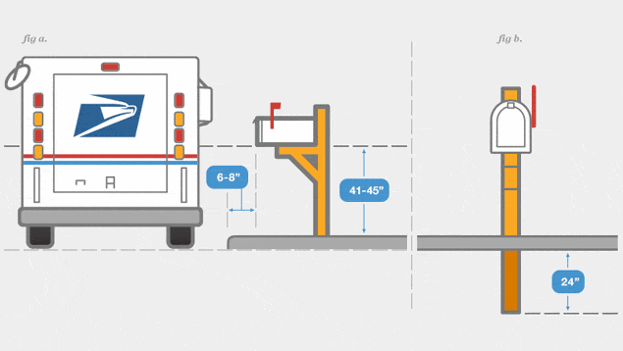
For more information go to www.usps.com

HARD TO RECYCLE EVENT

Saturday, October 3, 2015 at the Jefferson Township Fairgrounds, Mercer County. This is put on by Lawrence-Mercer Counties Recycling/Solid Waste Department. www.co.lawrence.pa.us/recycling

BE AWARE

A reminder that residents should be aware of their surroundings. If you see any suspicious activity, please call the proper authorities. Due to open eyes, any potential issues may be prevented. If you have any concerns, please contact us.

TOWNSHIP MEETINGS

The township monthly meetings are held on the first Wednesday of every month. The meetings are in the township office at 7pm. We welcome all comments and concerns about the township you live in.

LOOK TWICE

Spring not only brings out flowers, it brings out the motorcycle enthusiasts. Please look twice as new riders, experienced riders and the old timers are out and about.

REYNOLDS REBELS

The girls’ softball is in full swing! There are 84 girls playing this year 14 years old and younger, a total of 8 teams. You can catch a game Mon., Tues., Wed., or Thursdays at 6:00pm. We wish all the girls a safe and successful season. Come cheer them on!!

This newsletter is sponsored by:

